**EXPERIMENT NO. 1**

**AIM**: To study the different types of Network cables and network topologies.

**MATERIAL AND EQUIPMENT:**

* Various network cables (e.g., Ethernet cables, fiber optic cables, coaxial cables)
* Networking devices (e.g., routers, switches)
* Computers or laptops
* Whiteboard and markers (for explanation)
* Access to network simulation software (optional, for visualizing topologies)

**INTRODUCTION**

Network cables and topologies are fundamental components of computer networks. Network administrators and IT professionals need to understand the various types of cables and topologies to design, implement, and troubleshoot network infrastructure. This practical will provide hands-on experience and knowledge about different network cables and topologies.

**PROCEDURE**:

**Part 1:** Network Cable Types

* **Ethernet Cables**:

An Ethernet cable or Network cable is a cord used to connect devices together on a Network to transfer broadband data. They are used for connecting a laptop or desktop PC to a router, modem, internet hub, or printer, or for connecting any other wired network-capable peripherals together.

* **Fiber Optic Cables**:

There are these types of cables which transport optical data signals from an attached light source to the receiving device. We are pretty much aware of what is optical fibre and its uses in a wide variety of applications.

* **Coaxial Cables:**

This consists of solid copper or steel conductor plated with copper which is enclosed in the metallic braid and metallic tape. This is entirely covered with an insulated protective outer jacket. These types of cables are used for computer networking and audio-video networking.

* **Twisted Pair Cables:**

It has two or more insulated copper wires which are twisted with each other and are colour-coded. These types of wires are usually used in telephone cables and the resistance to external interference can be measured by the number of wires.

**Part 2**: Network Topologies

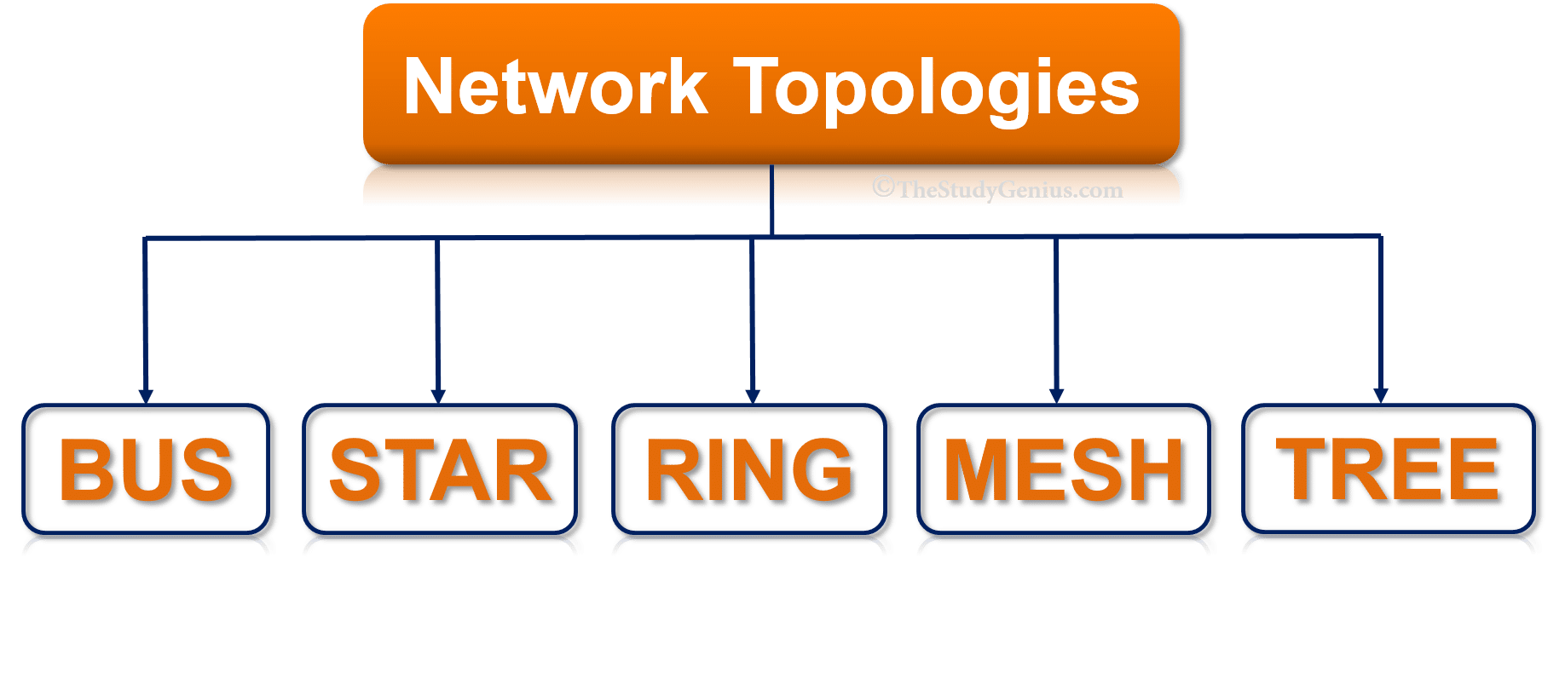

* **Bus Topology:**

In a bus topology, every computer is connected to a common bus. The bus is a single cable that carries data from one computer to another. If one computer wants to send data to another computer, it sends the data on the bus. All computers on the bus can see the data, but only the intended recipient will accept it..

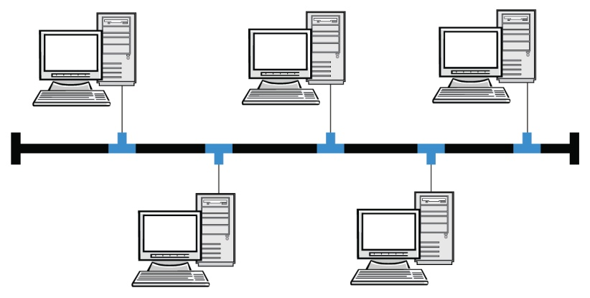

* **Star Topology:**

In a star topology, each device on the network is connected to a central hub. The hub acts as a gateway, providing a single point of connection for all devices on the network. Star topologies are commonly used in home and small office networks..

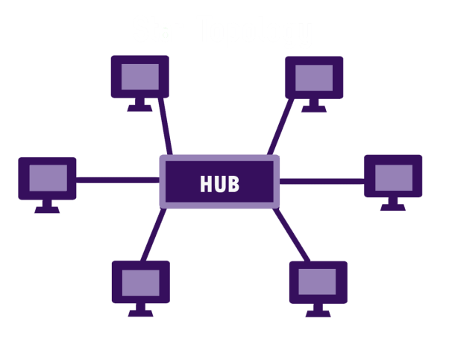

* **Ring Topology**:

In a ring topology, every node is connected to two other nodes, forming a loop. Data flows from one node to the next in a continuous sequence. Ring topologies are often used in fibre optic networks, where data can be transmitted at high speeds with minimal interference.

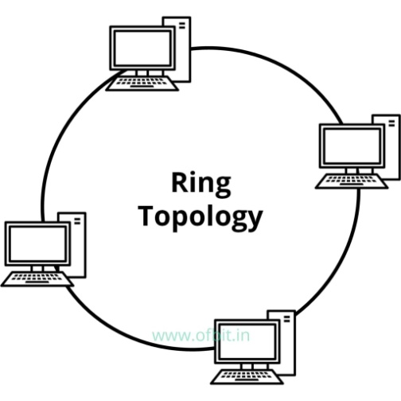

* **Mesh Topology**:

In computer networking, mesh topology is a type of network topology in which each node (computer or other devices) is connected to every other node in the network. A mesh topology is often used in large, complex networks because it is highly redundant and can accommodate a large number of nodes. If one node fails, the others can still communicate with each other.

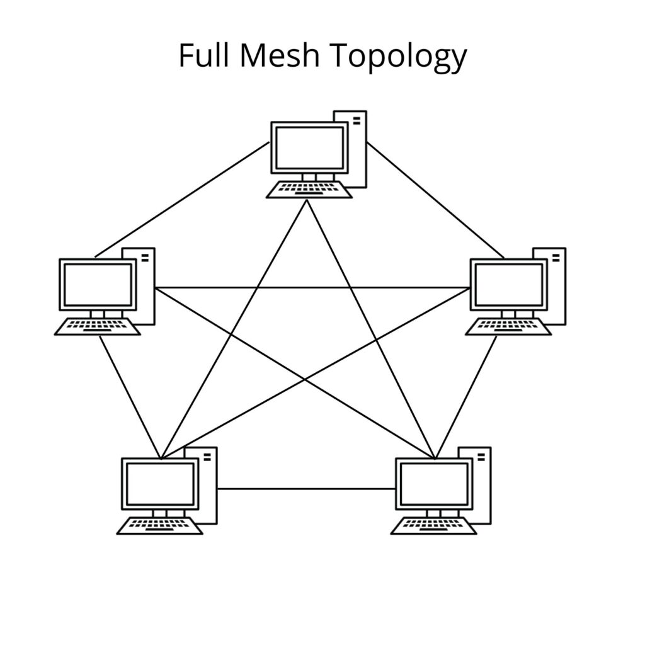

* **Tree Topology:**

In a tree topology, there is a central root node from which all other nodes branch out. This type of topology is often used in bus topology networks. Tree topology can be extended to an arbitrary depth, but it is usually only extended to two or three levels for the sake of simplicity.

